**Assignment**

**Course Title:** Electronics II

**Course Code:** EEE - 311

**Assignment No.:** 01

**Assignment Title:** Amplifier Design

**University of Chittagong**

Faculty of Engineering

Department of Electrical and Electronic Engineering

**Submitted To:**

**Dr. Mohammad Arif Iftakher Mahmood**

**Professor**

Department of Electrical & Electronic Engineering University of Chittagong

**Submitted By:**

**Name:** Md. Rakib Hasnat Akash

**ID:** 23702007

**Session:** 2022-23

**Semester:** 3rd

**Department:** Electrical & Electronic Engineering, University of Chittagong

**Date of Submission:**  01 March 2025

# **Design of a Class A Four-Stage Audio Amplifier Using 2N3904 BJT**

For my project, I am designing a Class A audio amplifier using a four-stage BJT configuration with the 2N3904 NPN transistor. These amplifiers provide **high gain**, **good frequency response**, and **minimal distortion**, **good fidelity** making them ideal for audio applications.

This amplifier follows a cascade design, where four identical stages are connected through RC coupling, meaning each stage’s output is linked to the next stage’s input using a capacitor.

The total gain is determined by multiplying the gain of each stage:

Total Gain = A1 × A2 × A3 × A4

To maintain high fidelity and minimal distortion, we need to consider the loading effect—where the input impedance of one stage influences the gain of the previous stage. To reduce this effect and keep the input impedance high, I have chosen a collector current (Ic) of 1mA, which is sufficient for stable operation.

This design ensures high-quality audio amplification with excellent signal clarity.

We need an amplifier with a total **Gain greater than, 200** (Gain > 46dB), and **a frequency response from less than 10Hz up to 1MHz**. We will supply this amplifier with a **12Vdc** power supply. We're going to use the popular **2N3904 NPN BJT**. The general purpose of 2N3904 transistor is for small signals and switching application. For our design we will use the 2N3904 in the linear region as an amplifier.

# **The 2N3904 Static Characteristic Curves:**

To determine the steady state working point of a 2N3904 transistor, we use DC Transfer Curve Analysis in PSpice tool. First, we set up a circuit with the collector connected to VCC = 12V, the emitter grounded, and a small base current (IB) applied via a resistor. In the Transfer Curve Analysis window, we maximize the view and set the cursor to VCE = 6V (which is VCC/2 for maximum output swing). We then find the IB curve that results in IC ≈ 1mA, and the best match is IB = 7.50µA, which gives IC = 1.07mA. This establishes the Q-point at VCE = 6V, IB = 7.50µA, and IC = 1.07mA, ensuring optimal operation with a good voltage swing.

# **Calculating Resistor Values for the Working Point of 2N3904:**

We have determined the steady state working point as:

* VCE = 6V
* IC = 1.07mA
* IB = 7.50µA

Now, let’s calculate the resistor values to achieve this biasing.

**Find Collector Resistor (R3**)

The collector resistor is calculated as:

R3 = VCE/IC = VCC/2IC = 12V/ (2 x 1.07mA) = 5607Ω​

Approximating, we choose R3 = 5.6kΩ.

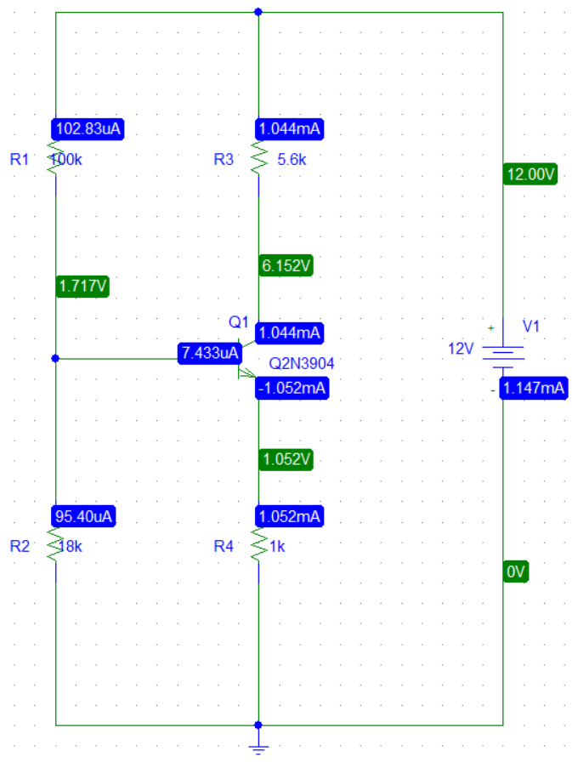

# **Find Base Voltage (VB) and Base Bias Resistors (R1, R2)**

The base voltage is set to VB = 1.7V, and we select the current through the bias resistors R1 and R2 to be 100µA (which is much higher than 10× IB for stability).

R1 = (VCC-VB)/IR1 = (12-1.7) V/100µA = 103000Ω.

Approximating, we choose R1 = 100kΩ.

R2 = VB/(IR1-IB) = 1.7V/ (100-7.5) µA = 18378Ω

Approximating, we choose R2 = 18kΩ.

**Find Emitter Resistor (R4)**

Considering the base-emitter forward voltage VF = 0.7V and assuming IE ≈ IC, the emitter resistor is:

R4 = (VB-VF)/IC = (1.7-0.7) V/1mA = 1000Ω

So, we choose R4 = 1kΩ.

**The Multistage Amplifier:**

This circuit is a 4-stage cascaded common-emitter Class A amplifier using 2N3904 NPN transistors, designed to amplify weak signals. Each stage follows a similar structure, where a transistor amplifies the input signal and passes it to the next stage through coupling capacitors (C2 to C5). These capacitors allow AC signals to pass while blocking DC, preventing unwanted shifts in biasing between stages. The resistor pairs (R1-R16) form voltage divider bias networks, ensuring stable transistor operation.

**The collector resistors (5.6kΩ) determine voltage gain**, while **the emitter resistors (1kΩ) provide negative feedback,** improving stability and reducing distortion. Each stage progressively increases the signal amplitude, making this design suitable for applications requiring high gain. The final amplified output is taken from Q3’s collector via C5, and the circuit operates with a 12V DC power supply (V2).

**Simulation Results: Input and Output Waveforms:**

This section presents the simulation results of the amplifier. The input and output waveforms are analyzed to evaluate the amplifier's performance in terms of gain, linearity, and distortion. The input signal was designed to replicate a small audio signal, while the output waveform demonstrates the amplifier's ability to amplify the signal effectively.

**Input Signal Parameters:**

The input signal to the amplifier was simulated using a VSIN source in PSpice. To replicate a typical small audio signal, such as that produced by **a human voice**, the input signal was designed with the following parameters:

**Amplitude (VAMPL):** 10 mV, representing the small signal level of a human voice.

**Frequency (FREQ):** 1 kHz, chosen as a standard mid-range frequency within the human voice spectrum. While the fundamental frequency of the human voice ranges from 85 Hz to 255 Hz, the harmonics extend up to 4 kHz, making 1 kHz a suitable test frequency for evaluating the amplifier's performance.

**DC Offset (VOFF):** 0 V, as the human voice is an AC signal with no DC component.

**Output Signal Parameters:**

The output waveform of the 4-stage Class A common emitter NPN amplifier is shown below. The output signal demonstrates the successful amplification of the input signal while maintaining its sinusoidal shape, indicating minimal distortion. The amplifier achieves a gain too which ensures that the small signal (10 mV) is amplified to a usable level. The output waveform confirms the amplifier's ability to handle audio signals within the human voice frequency range, making it suitable for audio applications.

**Input, Output, and Stage-wise Amplifier Waveforms**

To provide a comprehensive analysis of the amplifier's performance, this section includes a combined graph showing the following waveforms:

**Input Signal:** The original 10 mV, 1 kHz sinusoidal input signal.

**Output Signal (Across Capacitor and Load):** The final amplified output signal after passing through all four stages of the amplifier.

**Output of Each Stage:** The output waveform at the end of each of the four amplifier stages, demonstrating the progressive amplification of the signal.

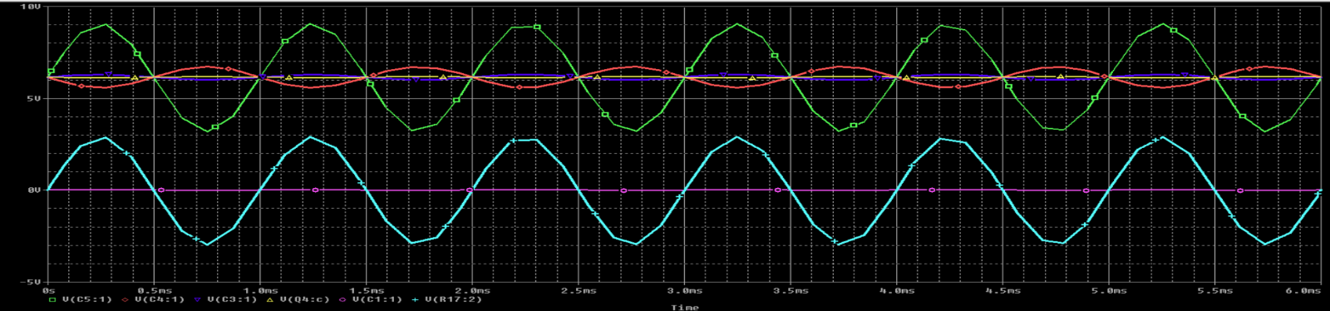

This combined graph allows for a clear comparison of the signal's transformation at each stage, highlighting the gain contribution of each stage and the overall amplification achieved by the 4-stage Class A common emitter amplifier.

**Calculating the Gain:**

Given Data-

**Input Signal:**

Positive peak voltage (Vin+): 10 mV

Negative peak voltage (Vin−​): -10 mV

Peak-to-peak input voltage (Vin(p−p)+) - (Vin(p−p)-​):

Vin(p−p) = (Vin+)​ − (Vin−) = 10mV−(−10mV) = 20mV

**Output Signal:**

Upper peak voltage (Vout+): 2.8957 V

Lower peak voltage (Vout-): -2.8949 V

Peak-to-peak output voltage Vout (p−p): ​(Vout+) - (Vout-) = 2.8957V−(−2.8949V) = 5.7906V

**Gain Calculation**

The voltage gain () of the amplifier is the ratio of the peak-to-peak output voltage to the peak-to-peak input voltage. It is calculated as:

Av=Vout(p−p)/Vin(p−p)

Av=5.7906 V/20 mV = 5.7906/ V0.02 V **= 289.53**

**The Voltage Gain: 289.53**

**Gain in Decibels (dB)**

The gain can also be expressed in decibels (dB) for better interpretation. The formula for gain in dB is:

Av(dB) = 20log10(Av)

Av(dB) = 20log10(289.53) ≈ 20×2.462 = **49.24dB**

**The Voltage Gain in dB: 49.24dB**

**Calculating the Current Gain:**

The current gain (β) of the amplifier is determined by using the current output and input current values.

Given:

Output Current (Iout) = 28.814 μA

Input Current (Iin) = 712.734 nA

Using the formula:

Current Gain = Output Curren t/ Input Current

Current Gain = 28.814×10−6A712.734×10−9A≈40.45

Therefore, the current gain of the amplifier is approximately **40.45.**

**Frequency Response:**

The following graph illustrates the frequency response of the amplifier, showing the relationship between the input and output voltages across a range of frequencies. The x-axis represents the frequency in hertz (Hz), while the y-axis displays the corresponding voltage levels

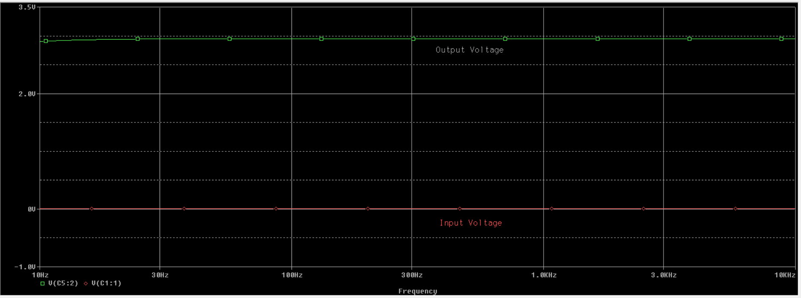

**Gain Response and Suitability:**

The gain response of the 4-stage Class A common emitter amplifier exhibits an **exponential increase from 0 to 100 Hz**, followed by a **flat response beyond 100 Hz**. This behavior is characteristic of a well-designed audio amplifier with coupling capacitors, which block very low frequencies (near 0 Hz) and provide consistent amplification for mid-range and high frequencies. The flat gain region ensures stable and uniform amplification across the frequency range of **100 Hz to 20 kHz**, which is ideal for audio applications.

This response is particularly well-suited for amplifying the human voice, as the fundamental frequencies of the human voice range from **85 Hz to 255 Hz**, with harmonics extending up to **4 kHz**. The low-frequency cutoff at 100 Hz does not significantly affect voice clarity, as most of the voice energy lies above this range. Additionally, the flat gain region ensures that the amplifier provides consistent amplification across the critical mid-range frequencies, resulting in clear and natural sound reproduction. With a gain of **289.53** (or **49.24 dB**), the amplifier is capable of effectively amplifying small voice signals to a usable level, making it an excellent choice for voice amplification applications.

**High-Frequency Response and Bandwidth Limitation:**

The following graph illustrates the amplifier's frequency response, showing that the gain remains flat up to 100 kHz before it begins to decrease. This behavior indicates the upper bandwidth limit of the amplifier, which is primarily influenced by the parasitic capacitances and the transistor's frequency limitations. While the amplifier performs well within the audio frequency range (20 Hz to 20 kHz), the decrease in gain beyond 100 kHz highlights the need for careful design considerations if extended high-frequency performance is required. For audio applications, however, this response is more than sufficient, as the human voice and most audio signals do not require amplification beyond 20 kHz.

**Phase vs. Frequency Analysis for the Amplifier**

The phase vs. frequency graph for the amplifier's output provides valuable insights into its phase response across the frequency spectrum. Here’s a detailed explanation based on the observed behavior**:**

**Phase Shift from 0 to 30 Hz**

The graph shows a phase shift starting from 0 degrees at very low frequencies (near 0 Hz) and gradually decreasing up to 30 Hz.

This phase shift is typical in amplifiers with coupling capacitors or high-pass filter networks. The capacitors block DC and very low frequencies, introducing a phase lead at low frequencies. As the frequency increases, the phase shift stabilizes, indicating that the amplifier is transitioning into its mid-frequency operating range.

The smooth and gradual phase shift in this range indicates that the amplifier is well-designed to handle low-frequency signals without abrupt changes, which is essential for maintaining signal integrity in audio applications.

**Stable Phase Response from 30 Hz to 100 kHz**

From 30 Hz to 100 kHz, the phase response remains relatively stable, with no phase shift.

This flat phase response is a key indicator of the amplifier's excellent performance in the mid-frequency range. It shows that the amplifier introduces minimal phase distortion across this range, which is critical for applications like audio amplification, where preserving the original waveform and timing is essential.

The stable phase response ensures that the amplifier can faithfully reproduce signals across the entire audio frequency range (20 Hz to 20 kHz) without introducing phase-related distortions, making it highly suitable for voice and music amplification.

**Phase Shift Beyond 100 kHz**

Beyond 100 kHz, the graph shows a gradual phase shift as the frequency increases. This phase shift is expected due to the amplifier's internal capacitances and transistor bandwidth limitations. At higher frequencies, parasitic effects and the finite gain-bandwidth product of the transistors cause the phase to lag.

The gradual phase shift (rather than an abrupt change) indicates that the amplifier is well-behaved even at high frequencies. This behavior is typical of well-designed amplifiers and does not negatively impact performance within the audio frequency range.

**Input Impedance:**

To calculate the input impedance, I placed a VSIN source with an amplitude of 1V at the input of my amplifier circuit. Then I set up the AC analysis by selecting AC Sweep, defining the sweep type as Linear, and setting the frequency range from 1kHz.

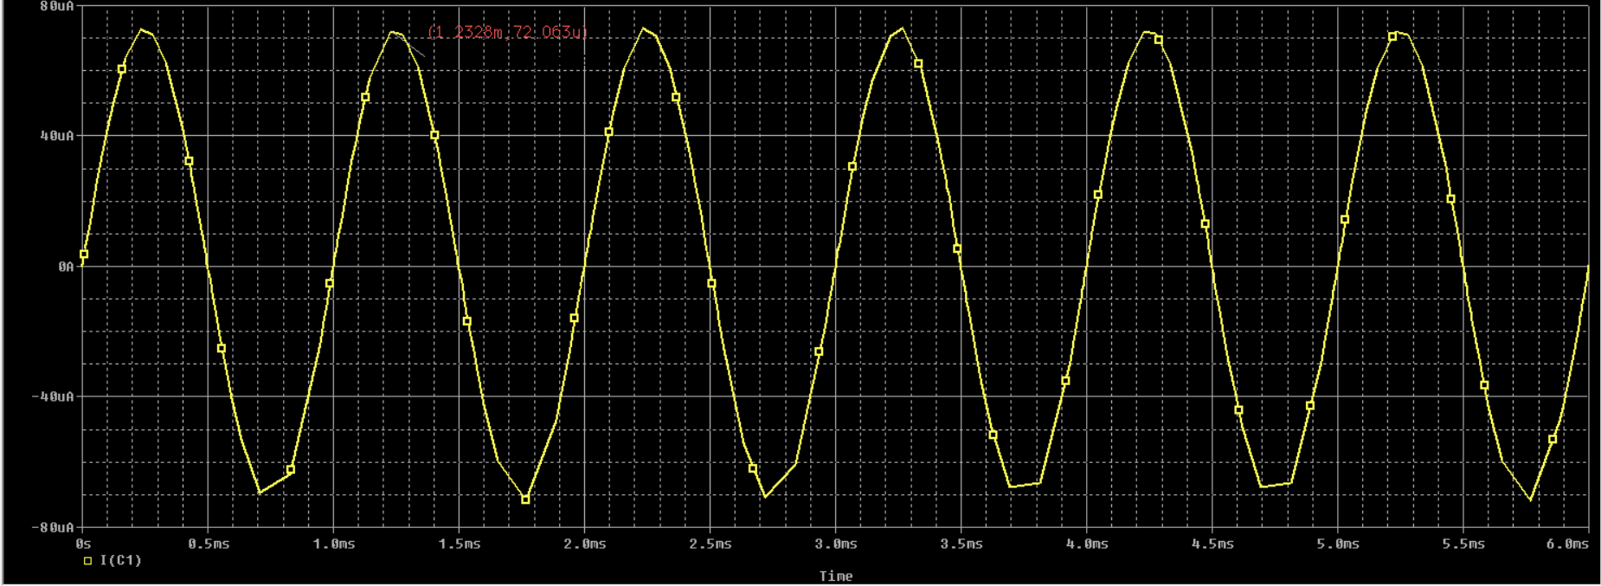

The input impedance using the formula:

Zin = Vin / IinZ

**Data:**

An input voltage (Vin) = 1V

An input current (Iin) = 72.063 μA,

Zin = Vin / IinZ

Zin = 1V / 72.063×10−6A ≈ **13.87kΩ**

**The Input Impedance: 13.87kΩ**

**Output Impedance:**

To find the output impedance using PSpice, first remove Vin and short it. Place an Isin source in parallel with R17, between the output node and ground. Set the Isin parameters to a DC offset of 0A, an amplitude of 1A, a frequency of 1kHz, and a phase of 0°. Run an AC sweep analysis. Measure Vout at the output node.

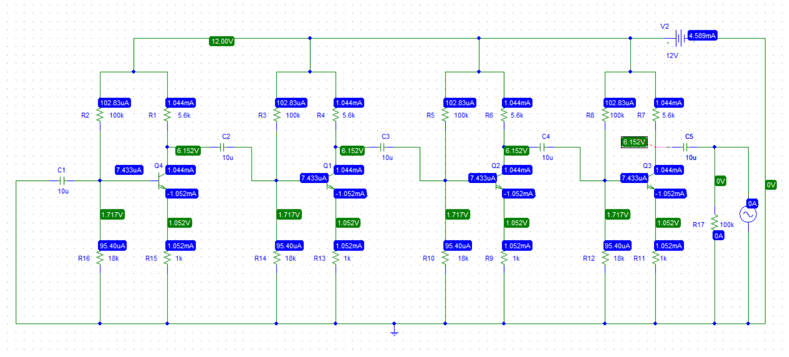

**Data:**

The voltage value is 5.0265kV

The current value is 1A

Output Impedance: Zout = Vout/ Isource

Zout = 5026.5V / 1A= **5026.5Ω**

**The Output Impedance: 5026.5Ω**

**Total Harmonic Distortion (THD) Analysis**

In this section, we analyze the Total Harmonic Distortion (THD) of the amplifier's output signal. THD is a critical metric for evaluating the quality of amplification, as it quantifies the distortion introduced by the amplifier. We examine the THD during the transient period, the stable state, and the overall signal to understand the amplifier's performance.

**Stable State Distortion**

After the transient period (after t = 2 seconds), the amplifier's output stabilizes, and the distortion decreases significantly. The THD during the stable state is 0.75%, which is an excellent result for amplification. This low THD indicates that the amplifier operates linearly and introduces minimal harmonic distortion once it reaches steady-state conditions. A THD of 0.75% is well within acceptable limits for most applications, including audio amplification, where THD values below 1% are considered high-quality.

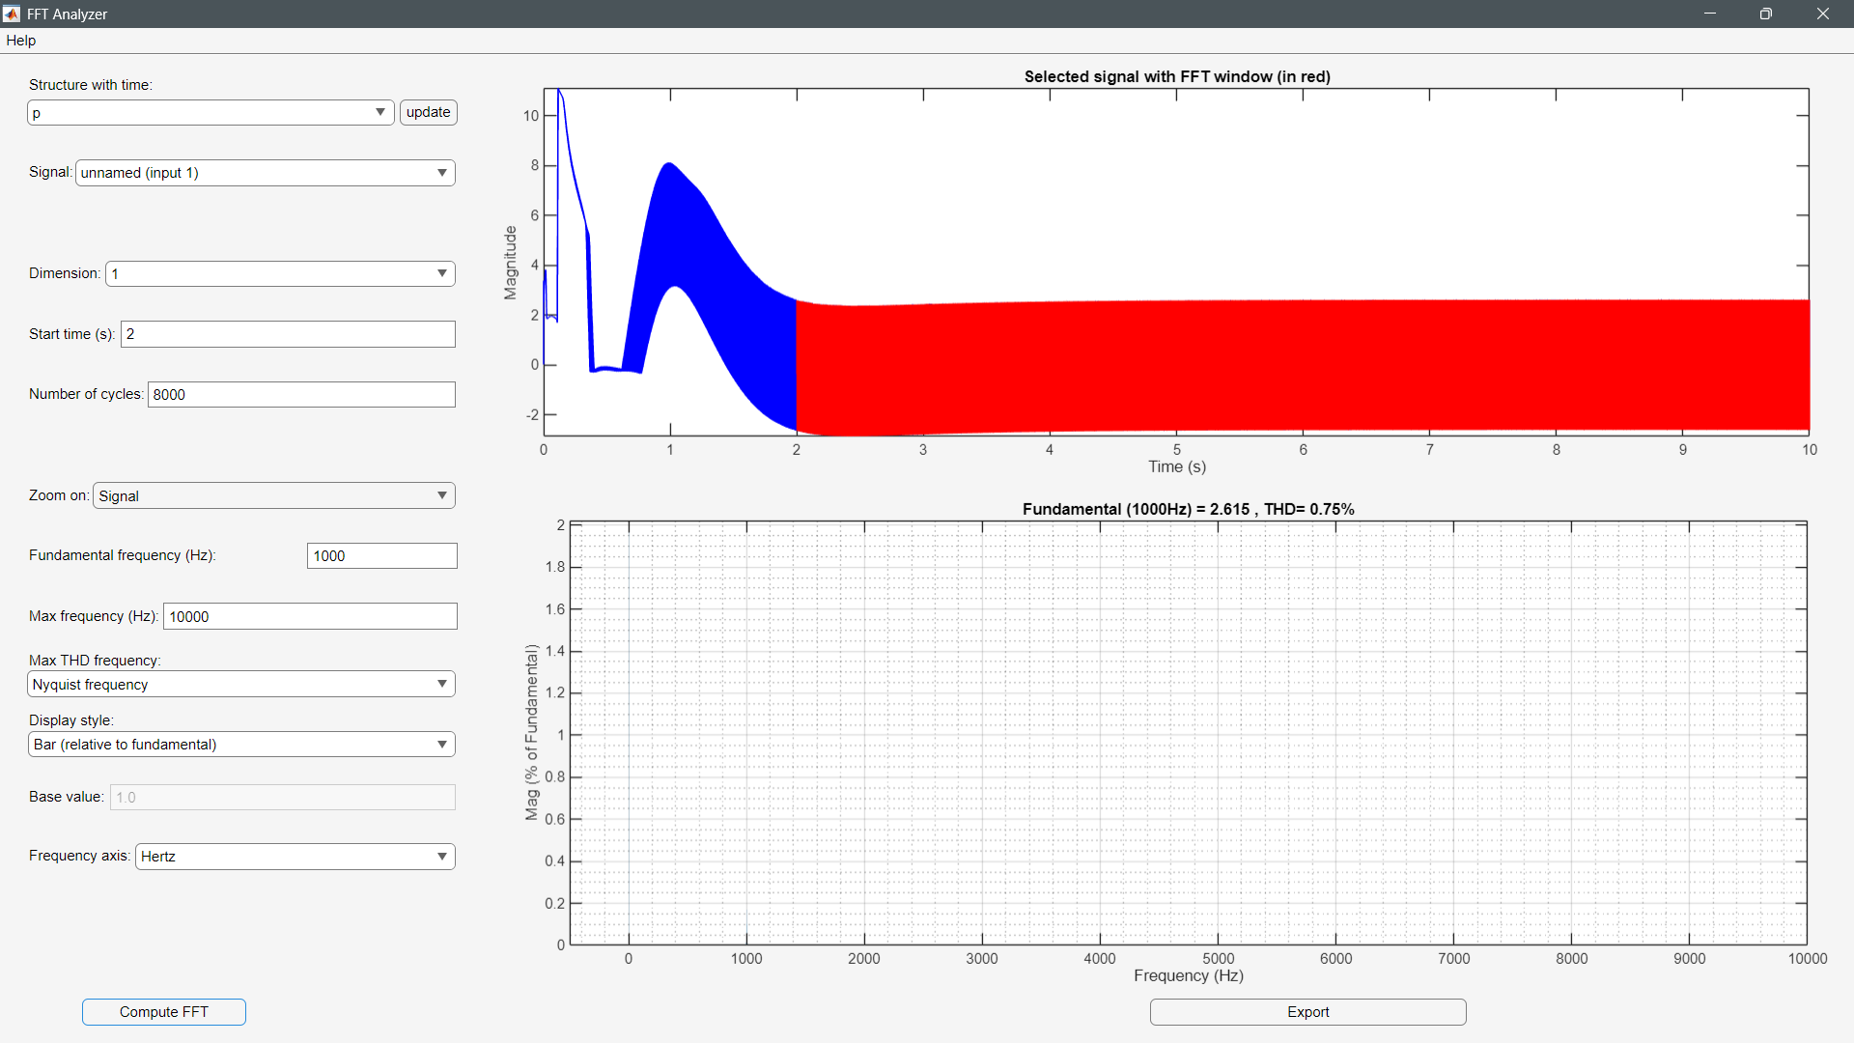

**Transient Period Distortion**

During the initial transient period (before t = 2 seconds), the amplifier's output exhibits significant distortion, with a THD of **50.01%.** This high level of distortion is expected during the transient period, as the system is settling into its steady-state behavior. The transient period is characterized by instability, oscillations, and nonlinear effects caused by energy storage elements (Capacitors) charging or discharging. The high THD during this period is not representative of the amplifier's true performance but rather reflects the system's initial response to the input signal.

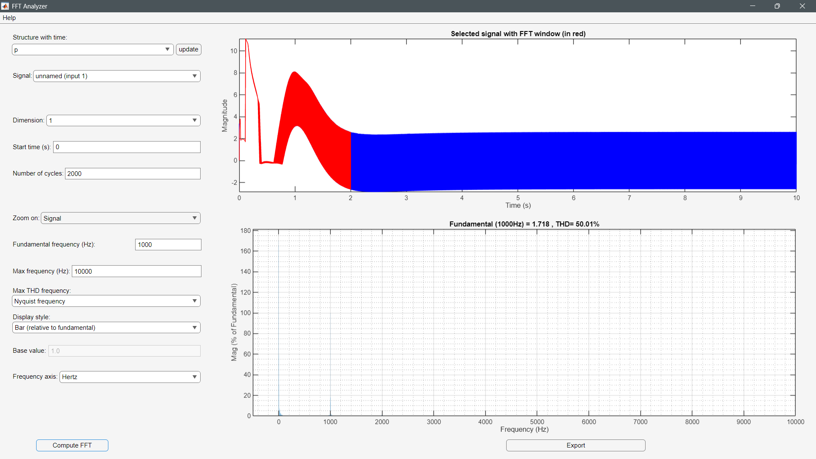

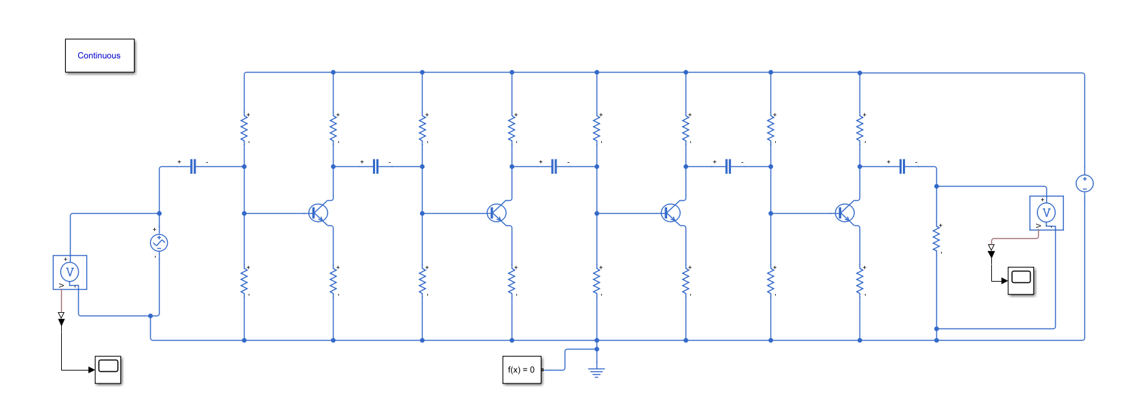

**Overall Distortion (Including Transient Period and Stable Period)**

When considering the entire signal, including the transient period, the overall THD is **18.82%**. This value is significantly higher than the stable-state THD due to the large distortion during the transient period. However, it is important to note that the overall THD is heavily influenced by the transient effects and does not accurately reflect the amplifier's performance during normal operation. For practical purposes, the stable state THD (0.75%) is a more meaningful metric**.**

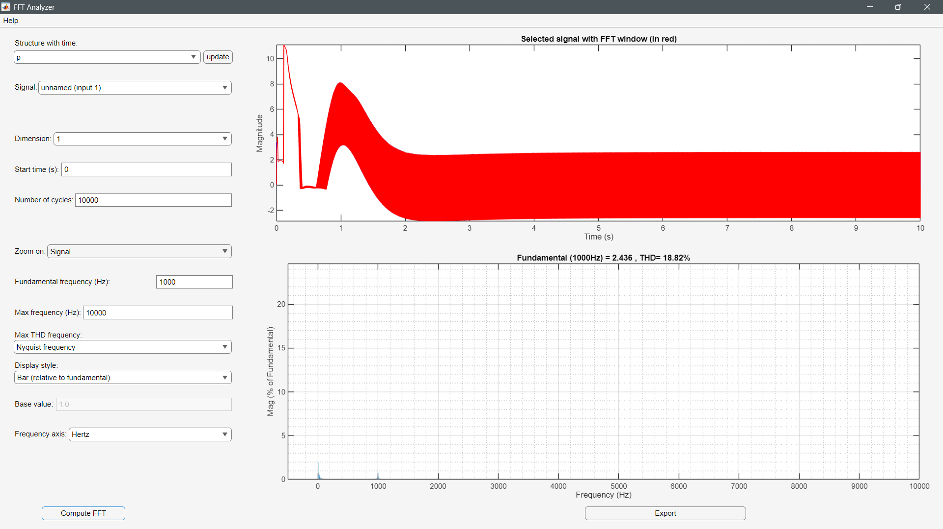

The amplifier exhibits excellent performance during the stable state, with a THD of **0.75%**, indicating minimal distortion and high signal fidelity. While the transient period contributes to higher overall THD, this is a normal characteristic of dynamic systems and does not affect the amplifier's steady-state performance. The results demonstrate that the amplifier is well-suited for applications requiring high-quality amplification with low distortion.

**Conclusion:**

The design and simulation of the 4-stage Class A NPN common emitter amplifier demonstrated exceptional performance, achieving a **voltage gain of 289.53** and a **current gain of approximately 40.45**, making it highly effective for amplifying small audio signals. The amplifier's **stable-state THD of 0.75%** indicates minimal distortion, confirming its ability to maintain signal integrity and deliver high-quality amplification. This low THD is particularly impressive, as it ensures that the amplified signal remains faithful to the original input, which is critical for audio applications.

The frequency response analysis further supports the amplifier's excellent performance, with a flat response up to **100 kHz** and a stable phase response from **30 Hz to 100 kHz**. This flat gain and phase response across the audio frequency range (20 Hz to 20 kHz) ensures that the amplifier introduces minimal distortion and preserves the original waveform, making it ideal for voice and music amplification. While the gain begins to decrease beyond 100 kHz due to parasitic capacitances and transistor limitations, this does not detract from its performance within the audio range.

Overall, the combination of **high gain**, **low THD**, and **stable frequency response** highlights the amplifier's robustness and suitability for practical audio applications. These results make it an excellent implementation of a multi-stage Class A amplifier design, capable of delivering clean and reliable amplification for a wide range of audio signals.

**Course Title:** Electronics II

**Course Code:** EEE 311

**Assignment No.: 01**

**Assignment Title: Amplifier Design**

**Name:** Md. Rakib Hasnat Akash

**ID: 23702007**

**Semester:** 3rd

**Session:** 2022-2023

**Date of Submission:** 01 March 2025